**Q. Prepare test case for testing your favorite app by using the concept of structural path testing.**

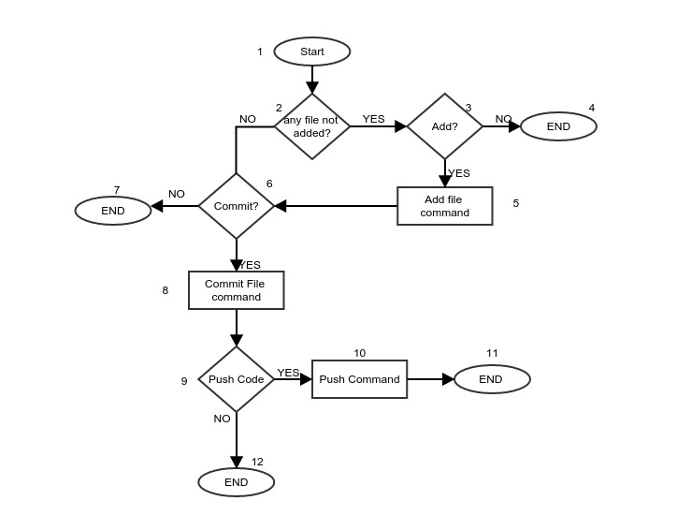

**Cyclomatic Complexity Calculation:**

|  |  |
| --- | --- |
| Edge (E): | 12 |
| Node (N): | 12 |
| Exit Points (P): | 4 |
| Cyclomatic Complexity (V=E-N+P): | 4 |

**Test Cases:**

|  |  |  |  |
| --- | --- | --- | --- |
| S.N | Test cases | Statement Covered | Branch Covered |
| a | 1 → 2 → 3 → 4 | 3 | 2 |
| b | 1 → 2 → 6 → 7 | 3 | 2 |
| c | 1 → 2 → 3 → 5 → 6 → 7 | 5 | 3 |
| d | 1 → 2 → 6 → 8 → 9 → 12 | 5 | 3 |
| e | 1 → 2 → 6 → 8 → 9 →10 → 11 | 6 | 3 |

**Statement Coverage Calculation:**

Total Statement = 12

|  |  |
| --- | --- |
| Test Case | Statement Coverage ( in %) |
| a | 33.33 |
| b | 33.33 |
| c | 50 |
| d | 50 |
| e | 58.33 |

**Branch Coverage Calculation:**

Total Branch = 4

|  |  |
| --- | --- |
| Test Case | Branch Coverage (in % ) |
| a | 50 |
| b | 50 |
| c | 75 |
| d | 75 |
| e | 75 |

Conclusion:

Test cases ‘c’, ‘d’ & 'e' will be selected as both of them have highest statement and branch coverage.

Select any open-source testing application and develop a report signifying the main features of it. Use snapshots to illustrate your viewpoint